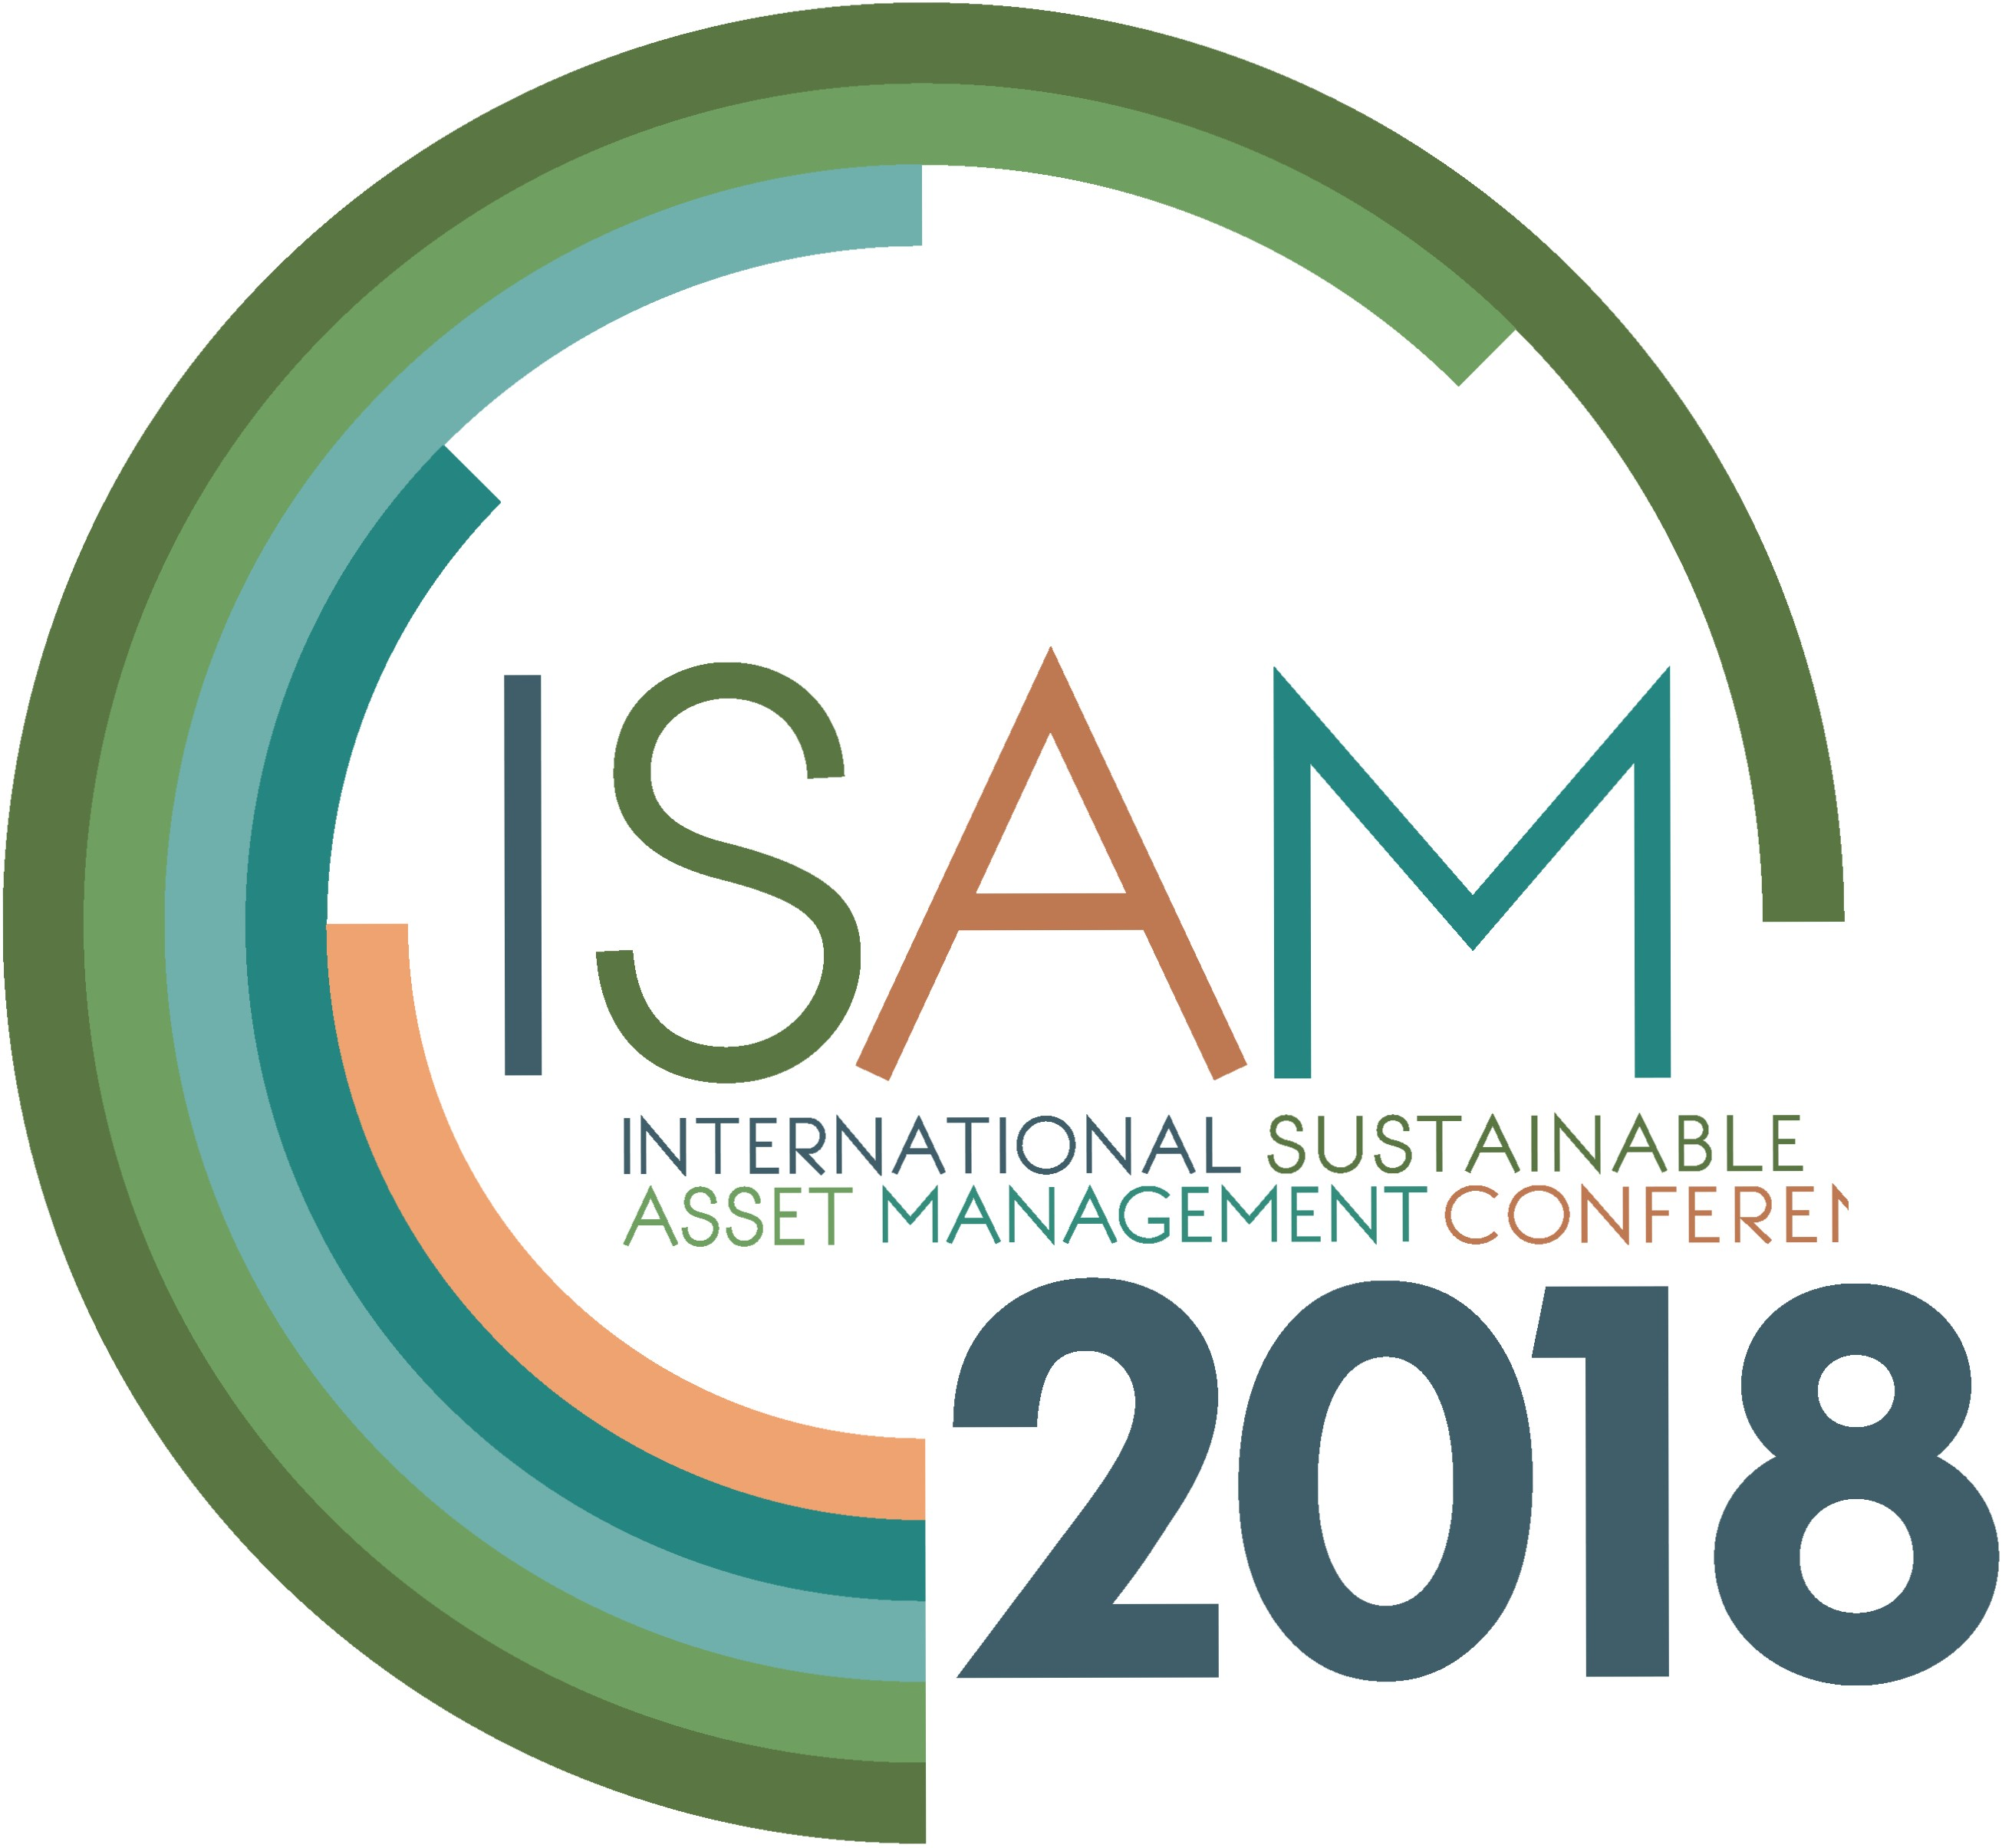

INTERNATIONAL SUSTAINABLE ASSET MANAGEMENT CONFERENCE