Benchmarking Occupant Comfort
Indoor Environmental Quality Considers a Broader Range of Criteria
by Travis West

Benchmarking of commercial office properties is being used by facility managers more and more frequently in today's market. Facility managers are responsible for reducing operating costs while maintaining high levels of customer satisfaction. Benchmarking is already being used to determine comparative salaries, the scope of job responsibilities, and even the level of service provided by outsourced contractors. Now, the University of California at Berkley, Center for the Built Environment (CBE), is offering an opportunity to benchmark indoor environmental quality.

TECHNICALAPPROACH
CBE's Occupant IEQ Survey provides a cost-effective method of rating building performance for a range of comfort and environmental criteria.
Indoor environmental quality (IEQ) goes beyond the standard issues that indoor air quality considers. IEQ includes thermal comfort, ventilation and indoor air quality, lighting quality, acoustics, interior spatial layout and furnishings, and cleanliness and maintenance. Indices and survey scales have been defined for each factor in order to quantify their effects on building occupants. Both physical and subjective data can be used to compare a building's IEQ performance against its design intent, or against the norms for a larger population of data (benchmarking IEQ). In response to queries from many types of property professionals, the CBE has developed cost-effective tools for quantifying and benchmarking both objective measurements of indoor environmental quality and how a building's occupants perceive that quality. This is done using a new online survey brochure and reporting tool.

DESCRIPTION

Research at Lawrence Berkeley National Laboratory suggests that improved indoor environments could produce annual productivity gains of as much as $168 billion in the U.S. Despite this huge potential, measuring IEQ and occupant satisfaction is still difficult and intrusive, creating a problem for building operators wishing to obtain data to justify building improvements. CBE is developing tools that enable building management to identify areas of poor IEQ performance and to prioritize areas for investment. The tools combine a web-based occupant satisfaction survey with a branching structure that assists with diagnosing causes of problems, reports that compare (benchmark) a given building's performance against a database of similar buildings, and low-cost, portable measurement equipment that can provide physical evidence of the building's environmental quality. It encompasses a wider range of environmental attributes than are found in current benchmarking practice. The database is designed to be easily augmented with new data. It allows comparisons to be made across the entire database, or for selected subsets based on factors such as building design, occupancy, geographic region, climate type, or season. Individual member companies can take it as a starting point and add data to it in the course of using the IEQ system in their operations. The database is compatible with the survey tools and physical measurement devices being developed at the Building Science Laboratory. An automated reporting format has been developed for quick and understandable communication to management. The format has already been used in a major building evaluation with a positive response from the building's facilities managers.
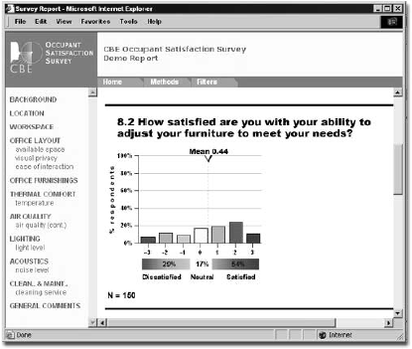

SUMMARY

Occasionally facility managers are called on to interpret the concerns raised by a building's occupants. Are their complaints about thermal comfort really about being too hot or too cold? Do they feel better when they go home because of indoor air quality, or is it because their furniture isn't adaptive? Or perhaps, an entire department's productivity is really based on a series of factors that can't always be anticipated by company managers. Whatever the reason, benchmarking indoor environmental quality appears to offer valuable insight into important occupant comfort issues. And that alone will help facility and building managers provide a better service for their customers.
To view more information on this process, or to contact someone at the Center for the Built Environment, visit their web site at: www.cbe.berkeley.edu/.

Travis West is the President of Building Air Quality, a Texas-based consulting firm. He can be reached at twest@baq1

